Database Basics MS SQL Exam – 16 Apr 2019
Exam problems for the “Database Basics” course @ SoftUni.
Submit your solutions in the SoftUni Judge system at https://judge.softuni.bg/

Airport

Section 1. DDL (30 pts)
You are given an E/R Diagram of the Airport:
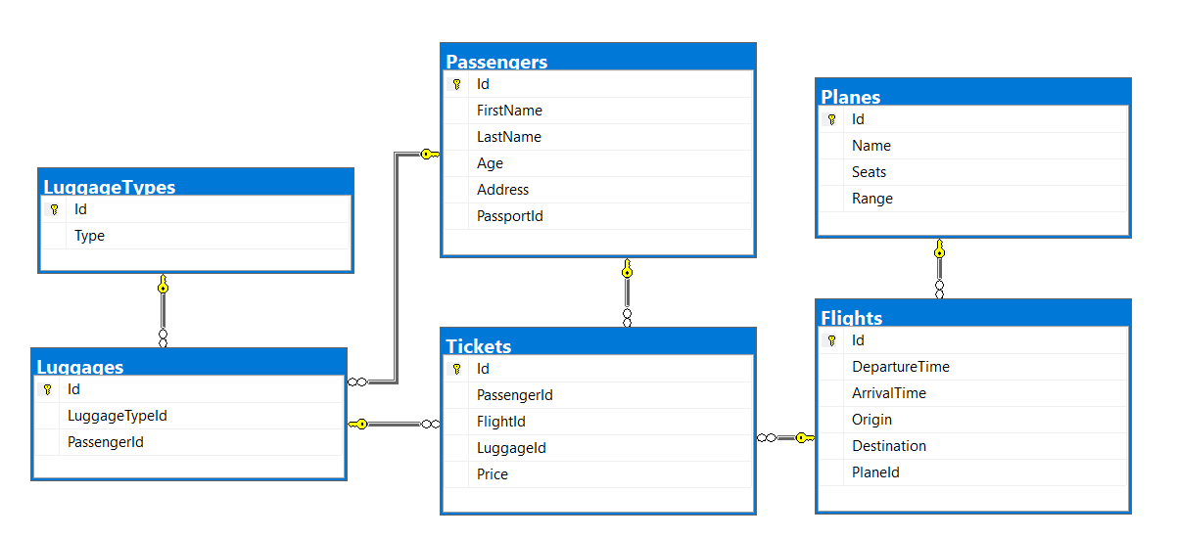
Crеate a database called Airport. You need to create 6 tables:
- Planes – contains information about the planes.
- Flights – contains information about the flights.
- Passеngers – contains information about the passengers
- LuggageTypes – contains information about the type of luggage's.
- Flights – contains information about the flights.
  - Each flight has a plane.
- Luggages – contains information about the luggage's.
  - Each luggage has a luggage type.
- Tickets – contains information about the tickets.
  - Each ticket has a passenger.
  - Each ticket has a flight.
  - Each ticket has a luggage.
Planes
Column Name | Data Type | Constraints
Id | Integer from 0 to 2,147,483,647 | Unique table identificator, Identity
Name | String up to 30 symbols | NULL is not allowed
Seats | Integer from 0 to 2,147,483,647 | NULL is not allowed
Range | Integer from 0 to 2,147,483,647 | NULL is not allowed

Flights
Column Name | Data Type | Constraints
Id | Integer from 0 to 2,147,483,647 | Unique table identificator, Identity
DepartureTime | Datetime | None
ArrivalTime | Datetime | None
Origin | String up to 50 symbols | NULL is not allowed
Destination | String up to 50 symbols | NULL is not allowed
PlaneId | Integer from 0 to 2,147,483,647 | NULL is not allowed, Relationship with table Planes

Passengers
Column Name | Data Type | Constraints
Id | Integer from 0 to 2,147,483,647 | Unique table identificator, Identity
FirstName | String up to 30 symbols | NULL is not allowed
LastName | String up to 30 symbols | NULL is not allowed
Age | Integer from 0 to 2,147,483,647 | NULL is not allowed
Address | String up to 30 symbols | NULL is not allowed
PassportId | String with exactly 11 symbols | NULL is not allowed

LuggageTypes
Column Name | Data Type | Constraints
Id | Integer from 0 to 2,147,483,647 | Unique table identificator, Identity
Type | String up to 30 symbols | NULL is not allowed

Luggages
Column Name | Data Type | Constraints
Id | Integer from 0 to 2,147,483,647 | Unique table identificator, Identity
LuggageTypeId | Integer from 0 to 2,147,483,647 | NULL is not allowed, Relationship with table LuggageTypes
PassengerId | Integer from 0 to 2,147,483,647 | NULL is not allowed, Relationship with table Passengers

Tickets
Column Name | Data Type | Constraints
Id | Integer from 0 to 2,147,483,647 | Unique table identificator, Identity
PassеngerId | Integer from 0 to 2,147,483,647 | NULL is not allowed, Relationship with table Passengers
FlightId | Integer from 0 to 2,147,483,647 | NULL is not allowed, Relationship with table Flights
LuggageId | Integer from 0 to 2,147,483,647 | NULL is not allowed, Relationship with table Luggages
Price | Decimal number with two-digit precision | NULL is not allowed

Database Design
Submit all of yours create statements to Judge (only creation of tables).

Section 2. DML (10 pts)
Before you start, you must import “DataSet-Airport.sql”. If you have created the structure correctly, the data should be successfully inserted without any errors.
In this section, you have to do some data manipulations:

Insert
Insert some sample data into the database. Write a query to add the following records into the corresponding tables. All Ids should be auto-generated.
Planes
Name | Seats | Range
Airbus 336 | 112 | 5132
Airbus 330 | 432 | 5325
Boeing 369 | 231 | 2355
Stelt 297 | 254 | 2143
Boeing 338 | 165 | 5111
Airbus 558 | 387 | 1342
Boeing 128 | 345 | 5541

Luggage Types
Type
Crossbody Bag
School Backpack
Shoulder Bag

Update
Make all flights to "Carlsbad" 13% more expensive.

Delete
Delete all flights to "Ayn Halagim".

Section 3. Querying (40 pts)
You need to start with a fresh dataset, so recreate your DB and import the sample data again (DataSet-Bitbucket.sql).

Trips
Select all flights from the database. Order them by origin (ascending) and destination (ascending).

Examples
Origin | Destination
Abelheira | Sabanitas
Adirejo | Koblain
Alfena | Makariv
Aubagne | Kitahama
… | …

The "Tr" Planes
Select all of the planes, which name contains "tr". Order them by id (ascending), name (ascending), seats (ascending) and range (ascending).

Examples
Id | Name | Seats | Range
31 | Trunyx cpp | 195 | 2653
86 | Yakitri | 321 | 1360
87 | Trilith | 223 | 4375
… | … | … | …

Flight Profits
Select the total profit for each flight from database. Order them by total price (descending), flight id (ascending).

Examples
FlightId | Price
58 | 828.43
43 | 819.84
… | …

Passengers and Prices
Select top 10 records from passengers along with the price for their tickets. Order them by price (descending), first name (ascending) and last name (ascending).

Examples
FirstName | LastName | Price
Brittne | Leggin | 447.82
Adolphe | Juste | 440.12
Rudyard | Kaveney | 439.96
… | … | …

Most Used Luggage's

Examples
Select luggage type and how many times was used by persons. Sort by count (descending) and luggage type (ascending).
Type | MostUsedLuggage
Garment Bag | 19
Wheeled Business Case | 19
Duffel Bag | 16
… | ..

Passenger Trips
Select the full name of the passengers with their trips (origin - destination). Order them by full name (ascending), origin (ascending) and destination (ascending).

Examples
Full Name | Origin | Destination
Adina Uvedale | Lawa-an | Hulei
Adolphe Juste | Boto | Pantubig
Adolphe Juste | Codrington | Kasiyan
… | … | ..

Non Adventures People
Select all people who don't have tickets. Select their first name, last name and age .Order them by age (descending), first name (ascending) and last name (ascending).

Examples
First Name | Last Name | Age
Felipa | Wabe | 89
Darius | Ellissen | 87
Eleen | Ummfrey | 86
… | … | ..

Lost Luggage's
Select all passengers who don't have luggage's. Select their passport id and address. Order the results by passport id (ascending) and address (ascending).

Examples
Passport Id | Address
105-40-7273 | 4 Haas Park
135-11-2922 | 435 Marquette Terrace
165-12-7011 | 2056 Kedzie Pass
… | ..

Count of Trips
Select all passengers and their count of trips. Select the first name, last name and count of trips. Order the results by total trips (descending), first name (ascending) and last name (ascending).

Examples
First Name | Last Name | Total Trips
Adolphe | Juste | 5
Neddie | Hugill | 4
Ashley | Peterkin | 3
… | … | ..

Full Info
Select all passengers who have trips. Select their full name (first name – last name), plane name, trip (in format {origin} - {destination}) and luggage type. Order the results by full name (ascending), name (ascending), origin (ascending), destination (ascending) and luggage type (ascending).

Examples
Full Name | Plane Name | Trip | Luggage Type
Adina Uvedale | Feedspan | Lawa-an - Hulei | Wheeled Business Case
Adolphe Juste | Babbleopia | Usagara - Ikhtiman | Upright Luggage
Adolphe Juste | Feednation | Le Mans - Grazhdanka | Duffel Bag
… | … | … | …

Most Expensive Trips
Select all passengers who have flights. Select their first name, last name, destination and price for the ticket. Take only the ticket with highest price for user. Order the results by price (descending), first name (ascending), last name (ascending) and destination (ascending).

Examples
First Name | Last Name | Destination | Price
Brittne | Leggin | Quitilipi | 447.82
Adolphe | Juste | Pantubig | 440.12
Rudyard | Kaveney | Kynopiastes | 439.96
… | … | … | …

Destinations Info
Select all destinations and trips count to them. Sort the result by trips count (descending) and destination name (ascending).

Examples
Destination | FilesCount
Daniwato | 3
Kobenhavn | 3
San Lorenzo | 3
… | …

PSP
Select all planes with their name, seats count and passengers count. Order the results by passengers count (descending), plane name (ascending) and seats (ascending)

Examples
Name | Seats | Passengers Count
Jabberbean | 56 | 6
Youbridge | 159 | 5
Yoveo | 247 | 5
… | … | …

Section 4. Programmability (20 pts)

Vacation
Create a user defined function, named udf_CalculateTickets(@origin, @destination, @peopleCount) that receives an origin (town name), destination (town name) and people count.
The function must return the total price in format "Total price {price}"
- If people count is less or equal to zero return – "Invalid people count!"
- If flight is invalid return – "Invalid flight!"

Example:
Query
SELECT dbo.udf_CalculateTickets('Kolyshley','Rancabolang', 33)
Output
Total price 2419.89

Query
SELECT dbo.udf_CalculateTickets('Kolyshley','Rancabolang', -1)
Output
Invalid people count!

Query
SELECT dbo.udf_CalculateTickets('Invalid','Rancabolang', 33)
Output
Invalid flight!

Wrong Data
Create a user defined stored procedure, named usp_CancelFlights
The procedure must cancel all flights on which the arrival time is before the departure time. Cancel means you need to leave the departure and arrival time empty.

Example:
Query
EXEC usp_CancelFlights
Output
(49 rows affected)

Deleted Planes
Create a new table "DeletedPlanes" with columns (Id,Name,Seats, Range). Create a trigger, which fires when planes are deleted. After deleting the planes, insert all of the data into the new table "DeletedPlanes".
Note: Submit only your CREATE TRIGGER statement!

Example usage:
Query
DELETE Tickets
WHERE FlightId IN (SELECT Id FROM Flights WHERE PlaneId = 8)
DELETE FROM Flights
WHERE PlaneId = 8

DELETE FROM Planes
WHERE Id = 8
Response
(1 rows affected)

(1 rows affected)

(1 rows affected)

(1 rows affected)

